Practical – 4
Submitted by: Om Gupta
Roll. No.: 214027

Explore and Write short note on the following network tools:
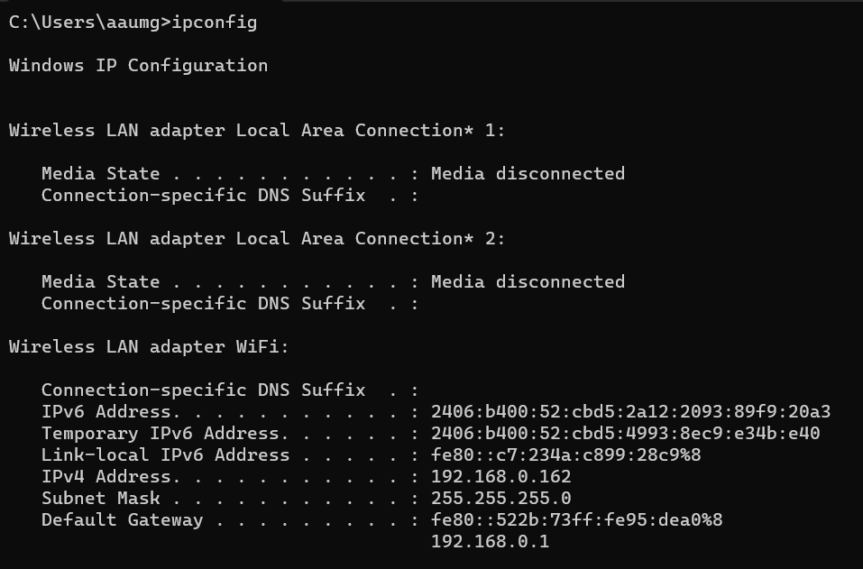
- ipconfig:
  - ipconfig is a command-line utility in Windows used to display the configuration of network interfaces on a local computer.
  - It provides information about the computer's IP address, subnet mask, default gateway, and more.
  - To find the IP address, subnet mask, class, host ID, and other details, simply open a command prompt and type ipconfig.

- b. ping:
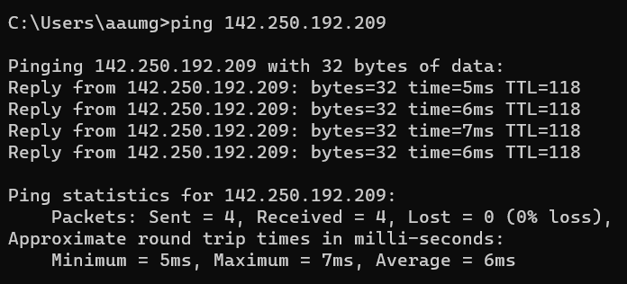
  - `ping` is a network utility used to test the reachability of a host on an Internet Protocol (IP) network.
  - It sends ICMP (Internet Control Message Protocol) echo request packets to a target host and waits for replies.
  - You can use `ping` to check if you can connect to other systems on your network by pinging their IP addresses.
- c. telnet:
  - `telnet` is a network protocol and command used to establish a remote connection to a device over a network.
  - It can be used for various purposes, including remote administration and troubleshooting.
  - You can use `telnet` to connect to remote servers and network devices, but it's less secure than SSH.
- d. ssh:
  - `ssh` (Secure Shell) is a network protocol and command used to securely access and manage remote systems over a network.
  - It provides encrypted communication, making it a more secure alternative to telnet for remote access.
  - To use SSH, you need an SSH client and a remote system with SSH server software installed.
- e. tracert/traceroute:
  - `tracert` (Windows) or `traceroute` (Unix/Linux) is a network diagnostic tool used to trace the route that packets take from your computer to a target host.
  - It helps you identify the network hops and latency along the path to a destination.
  - To use `tracert` or `traceroute`, simply enter the command followed by the target host's IP or domain name.

With the help of ping, check if you are connected to other systems of your network and find the route to connect to that system using tracert.
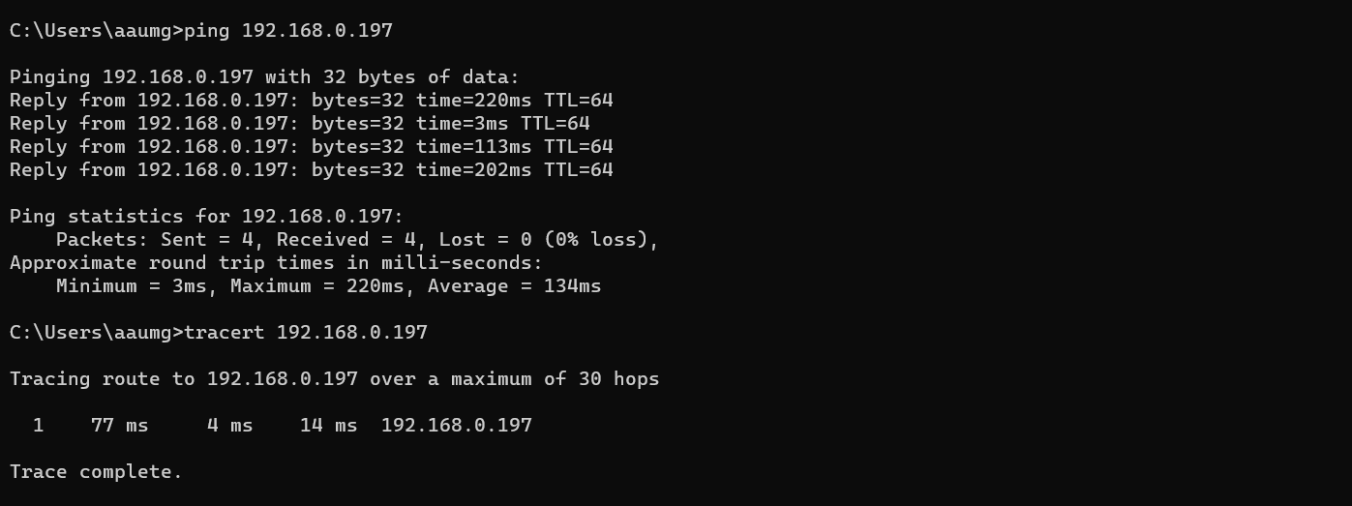
Explore netstat command and list all the processes which are using ports for TCP protocol.
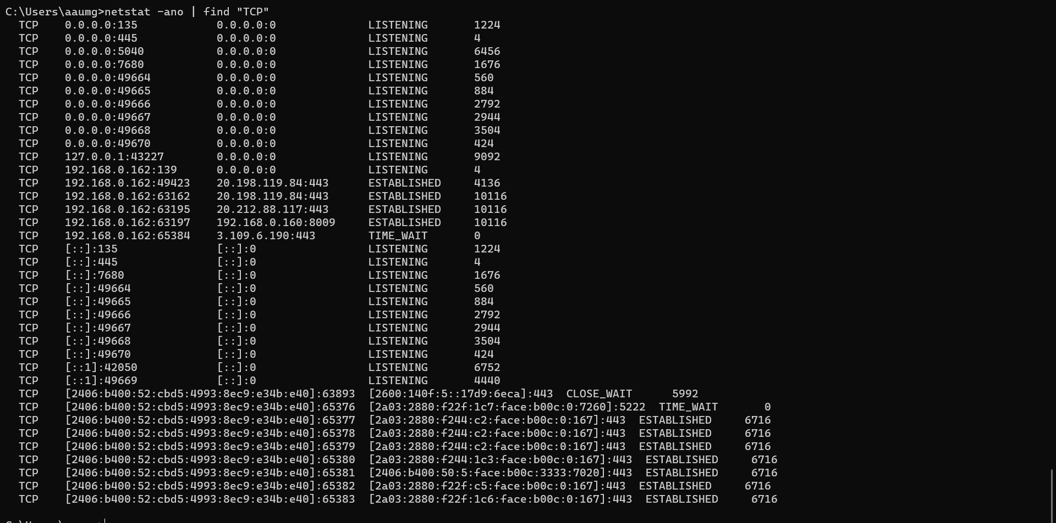
Display your systems IP Address, Subnet mask using ipconfig, and find out the following:
IP Address: 192.168.0.162
Subnet Mask: 255.255.255.0
- class of this IP address
Class C
- Host id
192.168.0.162
- Maximum no. of subnets
2⁰ = 1
(Since, the subnet mask is the default one of Class C and there are no borrowed bits, no subnetting happening actually.)
- Subnet address of your host
192.168.0.0

